

ONLINE FERTILIZER

* **Faculty: Ho Hoan Kiem**
* **Batch:**
* **Team Member:**
  + - * **Dang Hieu Thang**

**Ho Chi Minh City, March 1 2020**

Table of Contents

1. Review 1
   1. The Object Of The Project
   2. Functional Requirements
   3. Hardware/ Software Requirements
2. Review 2
   1. USE CASE DIAGRAM
   2. USE CASE DESCRIPTION
   3. CLASS DIAGRAM
   4. ENTITY RELATIONSHIP DIAGRAM (ERD)
   5. ENTITY DESCRIPTION
3. Review 3
   1. INTERFACE DESIGN WEB
   2. INTERFACE DEIGN APPLICATION

# 

REVIEW 1

Problem Definition

# The Object Of The Project

This project will aim to create a system that provides information about fertilizers so that users can exchange information and buy products. This system provides the following facilities:

* Search/View fertilizer information
* Comment on fertilizer
* Buy fertilizer
* Add, delete and update fertilizers(admin)
* Add, delete and update account(admin)
* Add, delete and update category(admin)
* View report(admin)
* View orders history

Customer Request   
 Specification

# Functional Requirements

Following is a list of functionalities of the system. More functionalities that you find appropriate can be added to this list.

Customer functions(Web):

* Guest may be signing up for an account
* Guest can login when having an account. If you enter the wrong error. When successfully importing, the customer can perform functions that the account has permission
* User can view information about fertilizers (No login required)
* Normal users can buy(a emai will sent to customer when checkout) and comment on fertilizer (Requires login)
* Users can change their personal information (Requires login)

Employee funtions(Winform):

* Employee can login when having an account
* Employee can Add/Update/Delete/View accounts
* Employee can Add/Update/Delete/View Products
* Employee can Add/Update/Delete/View Category
* Employee can view report about number product sell by category and product, best sell product last week and last month
* Employee can view user orders and support search orders by date
* Employee can export to excel user orders

# Hardware/ Software Requirements

By adding new technologies such as ASP.NET MVC 5, Bootstrap, Brazor, ADO.NET Entity Framework for web and ADO. NET, 3-layer architecture for application

1. **System Requirement**

* **For Users**
  + **Hardware**
    - CPU: Pentium IV 2.0 GHz or higher
    - RAM: 512 MB or higher
  + **Software**
    - OS: Windows 7/XP Professional/Server 2003…
    - Browser: Internet Explorer 8.0 or higher
* **For Software Developers**
  + **Hardware**
    - CPU: Pentium IV 2.0 GHz or higher
    - RAM: 512 MB or higher
  + **Software**
    - OS: Windows XP Professional/Server 2003…
    - Environment: Microsoft .NET Framework 3.5
    - Database Management System: Microsoft SQL Server 2008
    - IDE: Microsoft Visual Studio 2010
    - Web Server: Internet Information Services (IIS) JSP / Servlets Dev. Kit

|  |  |  |
| --- | --- | --- |
| **Date: March 1, 2020** | **Prepared by Project Group 4**  **Team Leader:** | **Approved by**  **Mr Ho Hoan Kiem** |
| **Signature** |  |  |

REVIEW 2

# USE CASE DIAGRAM

## Customer :

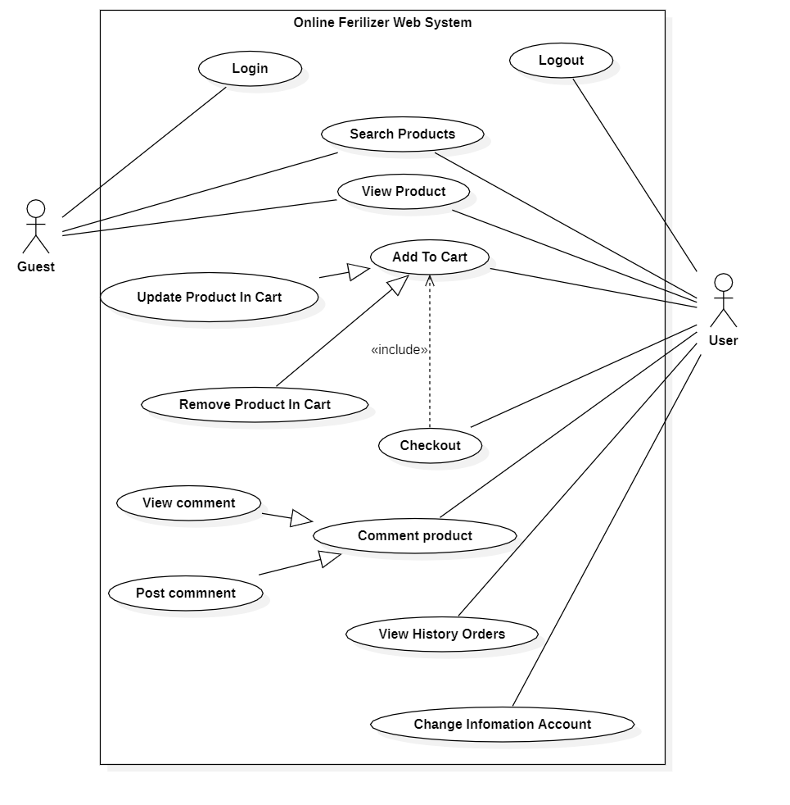

## Administrators :

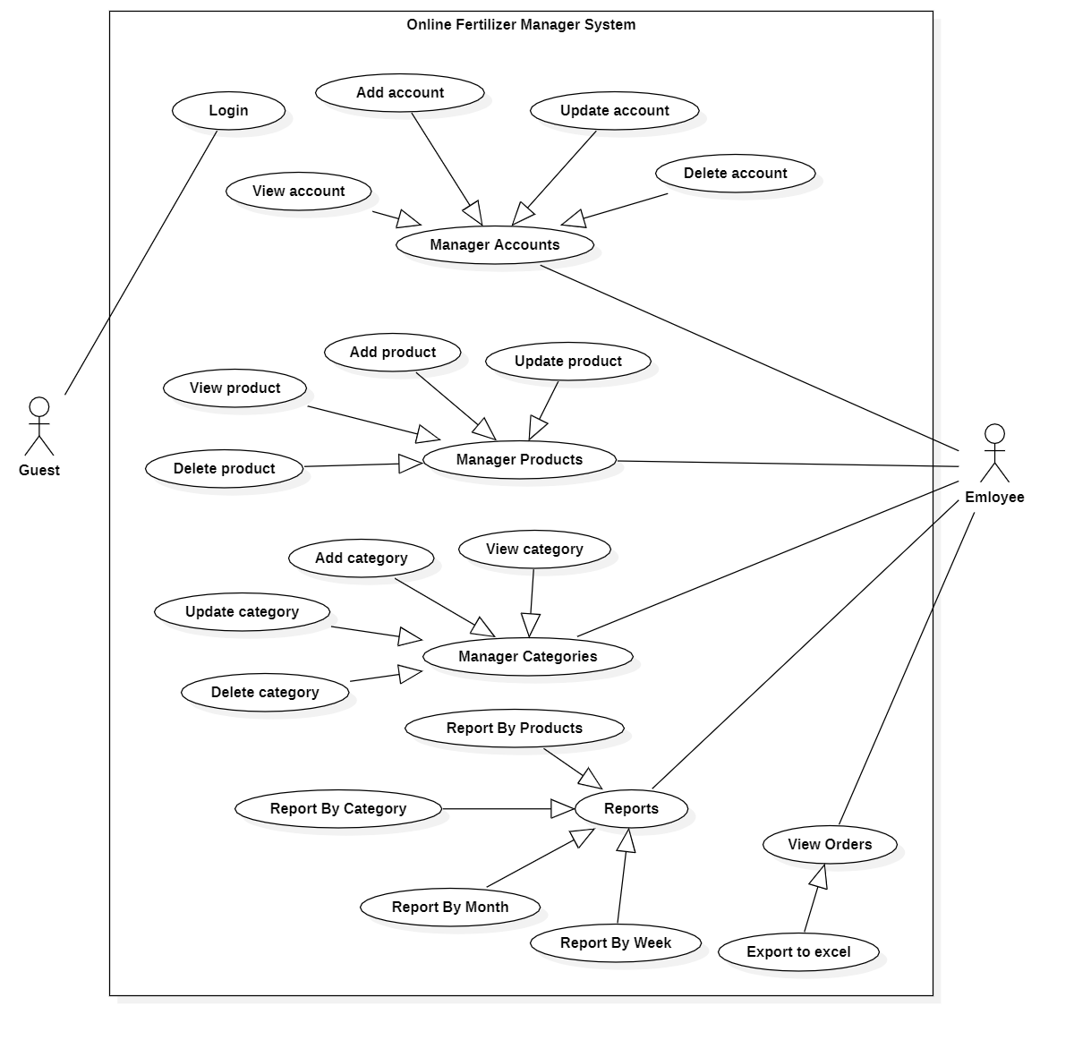

# USE CASE DESCRIPTION

## Actor:

* ***Guest*** is the person that uses this website/application but doesn’t register.
* ***User***  is the person that uses this website and register to become a member of website.
* **Employee :** The person(s) that manage and maintain this web site/application.

## Usecase:

|  |  |
| --- | --- |
| **Usecase** | Register |
| **Short Description** | Register account to become a member of the web site. |
| **Pre-Conditions** |  |
| **Post-Conditions** |  |
| **Main flow** | _Guest must provide mandatory information :   * Email. * Name * Password. * Confirm Password.   _Guest clicks on Register button.  _System checks the information which guest provided  _System create new account for guest that registers to this website/application.  _Guest becomes a member of this website. |
| **Alternative flow(s)** | _If guest clicks on the Reset button, all the field will be reset.  _If the mandatory information that guest provided, is missed or not exactly, system notifys the error. All cases are :   * Email is invalid or has existed in database. * Name must be required. * Password is less than 6 characters or more than 30 characters. * Confirm Password and Password are not the same. * Any fields are blank.   _System must be insert the date that guest register to become user. |

|  |  |
| --- | --- |
| **Use case** | View Products |
| **Short Description** | Read the products on this website. |
| **Pre-Conditions** |  |
| **Post-Conditions** |  |
| **Main flow** | _Customer access the news page.  _Customer drag the mouse over the link of product, read the summary of product.  _If customer want to see the details of product, he(she) clicks on the link of this product. All content of product will be shown. |
| **Alternative flow(s)** |  |

|  |  |
| --- | --- |
| **Usecase** | Login |
| **Short Description** | Log in website to use any function of member. |
| **Pre-Conditions** |  |
| **Post-Conditions** |  |
| **Main flow** | _Guest inputs the login information :   * Email. * Password.   _Guest clicks on the Login button.  _System check the Email and Password.  _If Email and Password are valid, system will move member to Homepage.  _ If email and password not valid, page will show account not found. |
| **Alternative flow(s)** |  |

|  |  |
| --- | --- |
| **Usecase** | Change Information Account |
| **Short Description** | Edit member’s information. |
| **Pre-Conditions** |  |
| **Post-Conditions** |  |
| **Main flow** | _Guest login to this website.  _Member clicks on the link to edit his(her) information, and access the private information page.  _Member edits information and save this action.  _System check this information and save it on the server.  _System notify report to member. |
| **Alternative flow(s)** |  |

|  |  |
| --- | --- |
| **Usecase** | Buy Products |
| **Short Description** | Customers can buy any products |
| **Pre-Conditions** |  |
| **Post-Conditions** |  |
| **Main flow** | _Guest login to this website.  _Member click Add To Cart any product.  _Member clicks on Checkout on Checkout Page  _System check this information and Transaction it on the server.  _System notify report to member. |
| **Alternative flow(s)** | _If any information transaction are invalid, system’ll notify the error, and rollback.  _If buy was successful, server will send email to buyer. |

|  |  |
| --- | --- |
| **Usecase** | Comment Products |
| **Short Description** | Customers can comment any products |
| **Pre-Conditions** |  |
| **Post-Conditions** |  |
| **Main flow** | _Guest login to this website.  _Member click on product detail.  _Member comment on comment fiel and click “Comment” button.  _System check this comment.  _System notify report to member. |
| **Alternative flow(s)** |  |

|  |  |
| --- | --- |
| **Usecase** | Manage Customers |
| **Short Description** | Manage all information about customer. |
| **Pre-Conditions** |  |
| **Post-Conditions** |  |
| **Main flow** | _Manage all information of customer. |
| **Alternative flow(s)** |  |

|  |  |
| --- | --- |
| **Usecase** | View Customer’s Information |
| **Short Description** | Administrator view customer’s information. |
| **Pre-Conditions** |  |
| **Post-Conditions** |  |
| **Main flow** | _Administrator choose the customer that administrator wants to see information.  _Administrator clicks on the “View Information” button.  _System shows the customer’s information to the administrator. |
| **Alternative flow(s)** | _If server notifies any error when it’s processing, system must be write report into Log file. |

|  |  |
| --- | --- |
| **Usecase** | Administrator Edit Account |
| **Short Description** | Edit member’s information. |
| **Pre-Conditions** |  |
| **Post-Conditions** |  |
| **Main flow** | _Admin can edit account infomation  _System check this information and save it on the sql.  _System notify report to member. |
| **Alternative flow(s)** |  |

|  |  |
| --- | --- |
| **Usecase** | Add Product |
| **Short Description** | Add Product of this website. |
| **Pre-Conditions** |  |
| **Post-Conditions** |  |
| **Main flow** | _Administrator can add new products.  _Administrator chooses the correlative function.  _System passes administrator to the page that administrator can interact with system. |
| **Alternative flow(s)** |  |

**Us**

|  |  |
| --- | --- |
| **Usecase** | Update Product |
| **Short Description** | Update Product of this website. |
| **Pre-Conditions** |  |
| **Post-Conditions** |  |
| **Main flow** | _Administrator can edit products.  _Administrator chooses the correlative function.  _System passes administrator to the page that administrator can interact with system. |
| **Alternative flow(s)** |  |

|  |  |
| --- | --- |
| **Usecase** | Delete Product |
| **Short Description** | Delete Product of this website. |
| **Pre-Conditions** |  |
| **Post-Conditions** |  |
| **Main flow** | _Administrator can delete products.  _Administrator chooses the correlative function.  _System passes administrator to the page that administrator can interact with system. |
| **Alternative flow(s)** |  |

**Ecas**

**Usecase**

|  |  |
| --- | --- |
| **Usecase** | View Report |
| **Short Description** | View all information about transaction. |
| **Pre-Conditions** |  |
| **Post-Conditions** |  |
| **Main flow** | _Administrator can view.  _Transaction reporting in the days, months, years .  _System passes administrator to the page that administrator can interact with system. |
| **Alternative flow(s)** |  |

|  |  |
| --- | --- |
| **Usecase** | View Orders Information |
| **Short Description** | View details information of Transaction. |
| **Pre-Conditions** |  |
| **Post-Conditions** |  |
| **Main flow** | _Administrator chooses the transaction that administrator wants to see information.  _System shows the details information of this transaction. |
| **Alternative flow(s)** | _ |

|  |  |
| --- | --- |
| **Usecase** | Search Products |
| **Short Description** | Search all products about this site. |
| **Pre-Conditions** |  |
| **Post-Conditions** |  |
| **Main flow** | _Administrator inputs the information that wants to see in the search field.  _Administrator clicks on the “Search” button Or onKeydown  _System shows the result to the administrator. |
| **Alternative flow(s)** |  |

# CLASS DIAGRAM

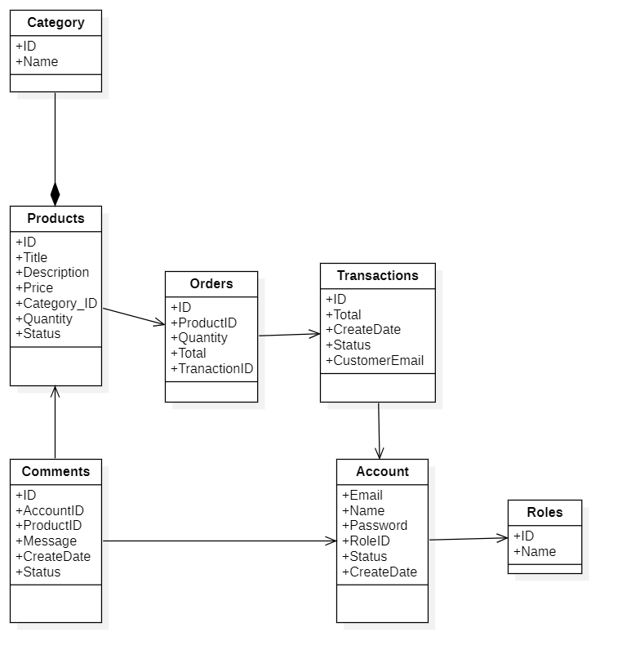

# ENTITY RELATIONSHIP DIAGRAM (ERD)

Entity

Entity Relationship

One to  
 many relationship

# ENTITY DESCRIPTION

One to One

relatioship

**1.Account Customer :**

**2. Product:  
3. Category :**

**Product**

**Account**

**4. Role :  
  
  
  
  
  
  
  
  
5. Transaction :  
  
6. Order :**

**Transaction**

**Role**

**Category**

**Order**

**7. Comment:**

**Comment**

**TABLE DESIGN**

1. **Accounts:**

|  |  |  |  |  |  |
| --- | --- | --- | --- | --- | --- |
| **No** | **Column Name** | **Data Type** | **Size** | **Check** | **Description** |
| 1 | **🗝**Email | Varchar | 15 | Not Null | Customer Email |
| 2 | Name | Varchar | 200 | Not Null | Customer’s Name |
| 3 | Password | Varchar | 50 | Not Null | Customer’s password |
| 4 | RoleID | Int |  | Not Null | Customer’s role |
| 4 | Status | Bit |  | Not Null | Customer’s status |

1. **Roles:**

|  |  |  |  |  |  |
| --- | --- | --- | --- | --- | --- |
| **No** | **Column Name** | **Data Type** | **Size** | **Check** | **Description** |
| 1 | **🗝**ID | Int |  | Not Null | Role ID |
| 2 | Name | Nvarchar | 50 | Not Null | Role Name |

1. **Products :**

|  |  |  |  |  |  |  |  |  |  |
| --- | --- | --- | --- | --- | --- | --- | --- | --- | --- |
| **No** | **Column Name** | | **Data Type** | | **Size** | **Check** | | **Description** | |
| 1 | **🗝**ID | Int | |  | | | Not Null | | Product ID |
| 2 | Title | Nvarchar | | 500 | | | Not Null | | Product Name |
| 3 | Description | Nvarchar | | 2000 | | | Not Null | | Product Description |
| 4 | Price | Float | |  | | | Not Null | | Product Price |
| 5 | CategoryID | Int | |  | | | Not Null | | Product Category |
| 6 | Quantity | Int | |  | | | Not Null | | Product Quantity |
| 7 | Status | Bit | |  | | | Not Null | | Product Status |

1. **Category:**

|  |  |  |  |  |  |
| --- | --- | --- | --- | --- | --- |
| **No** | **Column Name** | **Data Type** | **Size** | **Check** | **Description** |
| 1 | **🗝** ID | Int |  | Not Null | Category ID |
| 2 | Name | Nvarchar | 50 | Not Null | Category Name |

1. **Transactions:**

|  |  |  |  |  |  |
| --- | --- | --- | --- | --- | --- |
| **No** | **Column Name** | **Data Type** | **Size** | **Check** | **Description** |
| 1 | **🗝** ID | Int |  | Not Null | Transaction ID |
| 2 | Total | Float |  | Not Null | Total Price Transaction |
| 3 | CreateDate | Date |  | Not Null | Day Tranfer Transaction |
| 4 | CustomerEmail | Varchar | 50 | Not Null | Email customer tranfer |
| 5 | Status | bit |  | Not Null | Transaction Status |

1. **Orders :**

|  |  |  |  |  |  |
| --- | --- | --- | --- | --- | --- |
| **No** | **Column Name** | **Data Type** | **Size** | **Check** | **Description** |
| 1 | **🗝** ID | Int |  | Not Null | Order ID |
| 2 | ProductID | Int |  | Not Null | Product ID |
| 3 | Quantity | Int |  | Not Null | Quantity of Product Buy |
| 4 | Total | Float |  | Not null | Total price of order |
| 5 | TransactionID | int |  | Not Null | TransactionID |

1. **Comments:**

|  |  |  |  |  |  |
| --- | --- | --- | --- | --- | --- |
| **No** | **Column Name** | **Data Type** | **Size** | **Check** | **Description** |
| 1 | **🗝**ID | int |  | Not Null | Comment ID |
| 2 | CustomerEmail | Varchar | 50 | Not Null | Email Of customer comment |
| 3 | ProductID | Int |  | Not Null | Product comment |
| 4 | Message | Nvarchar | 500 | Not Null | Content of comment |
| 5 | CreateDate | Date |  | Not Null | Create Day |
| 6 | Status | Bit |  | Not Null | Comment Status |

**Note**

**🗝** Primary key

✓ Unique constraint

**TABLE RELATIONSHIP DIAGRAM**



|  |  |  |
| --- | --- | --- |
| **Date: March 28, 2020** | **Prepared by Project Group T**  **Team Leader:** | **Approved by**  **Mr. Ho Hoan Kiem** |
| **Signature** |  |  |

REVIEW 3

# INTERFACE DESIGN WEB

### Login

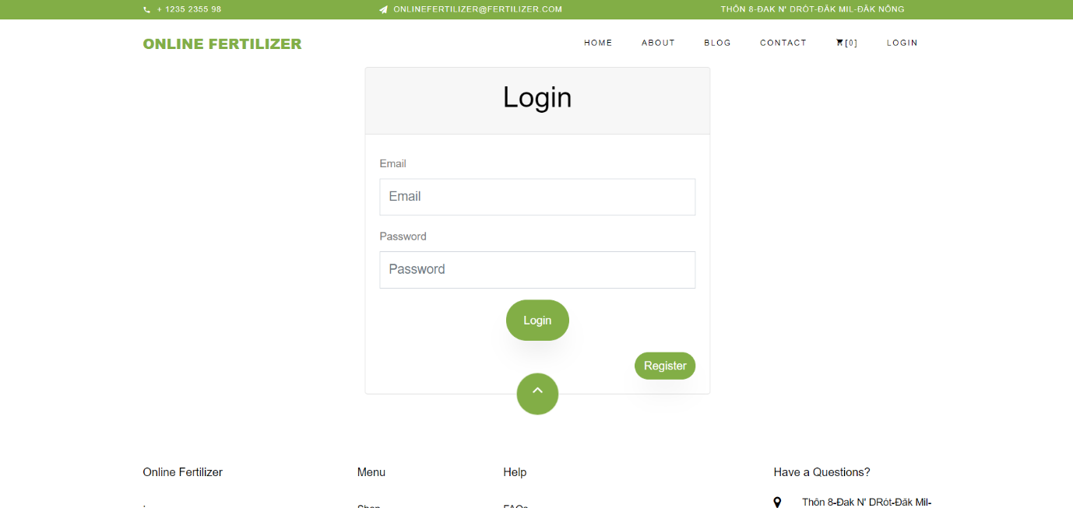

### Reigster

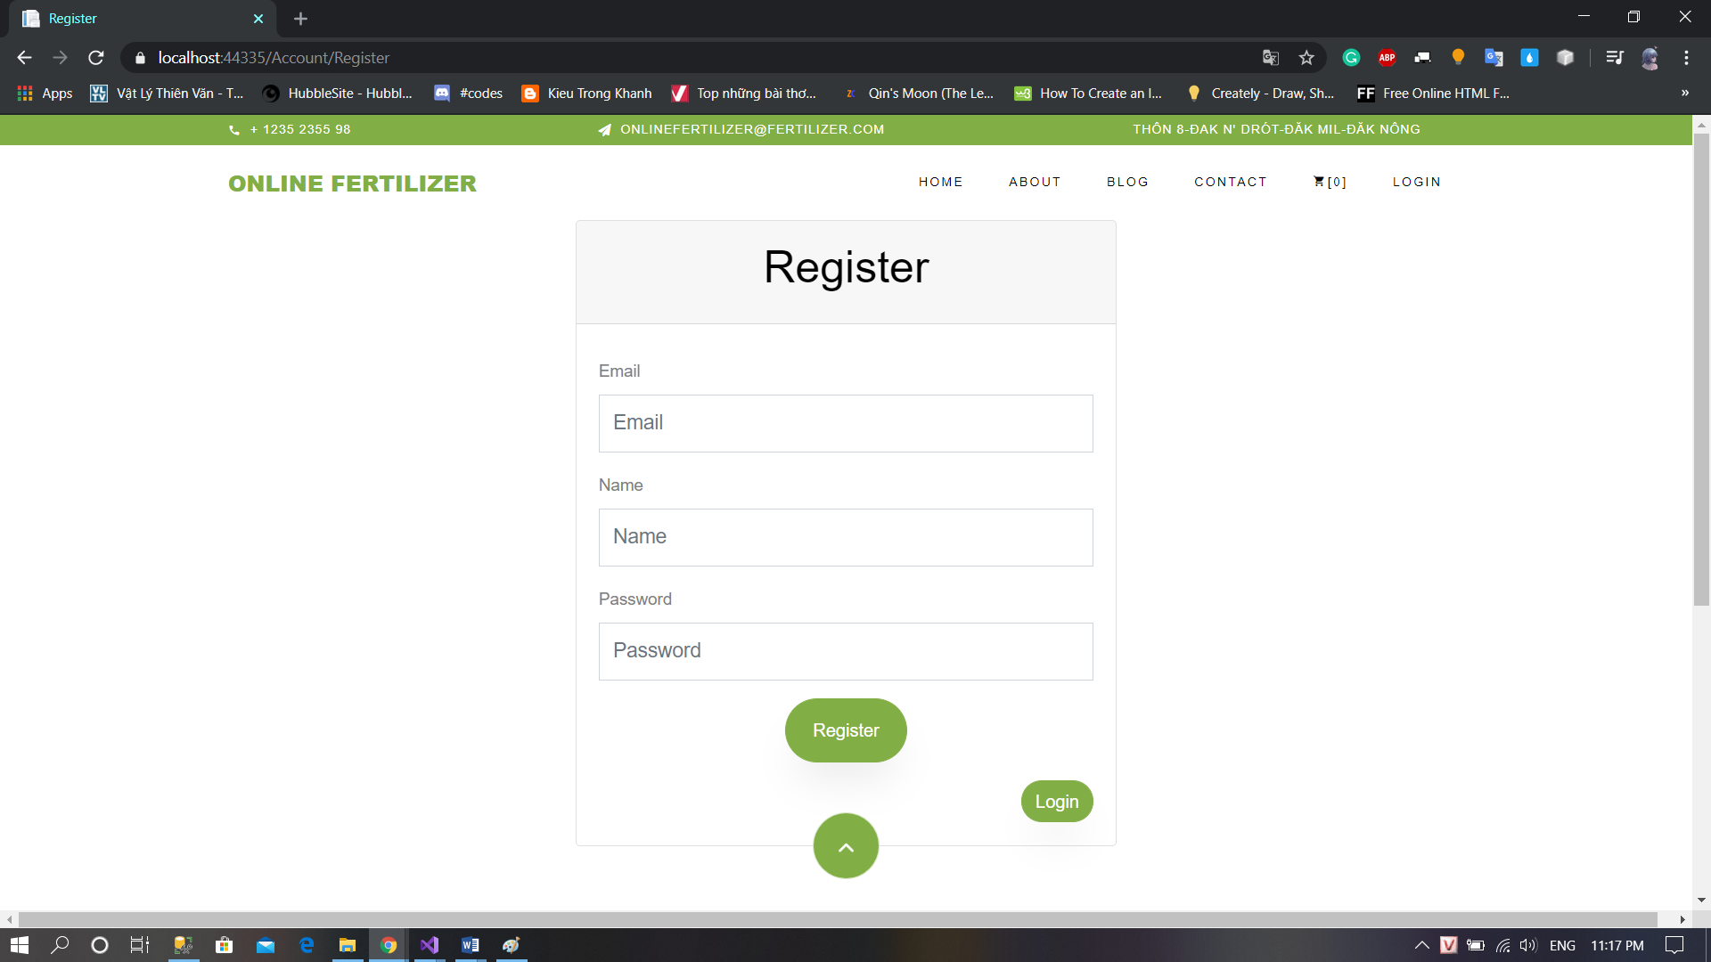

### Change Account Information

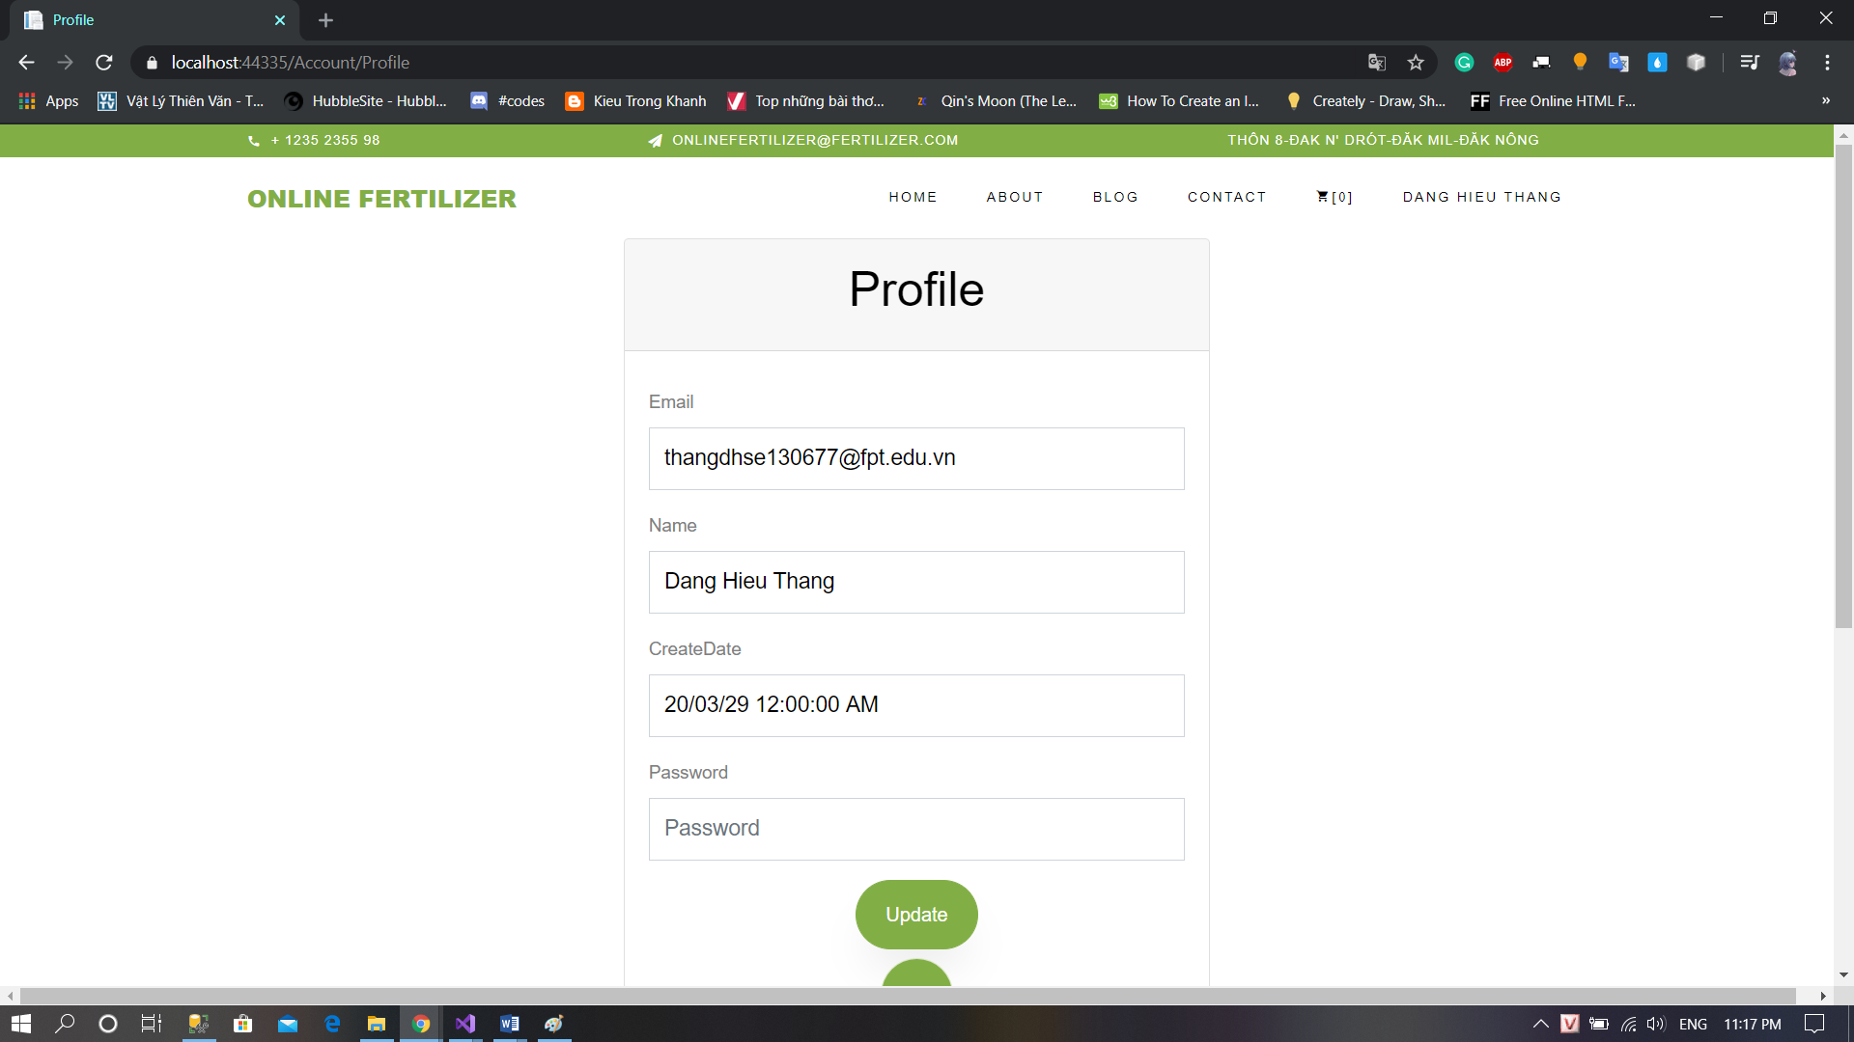

### History Order

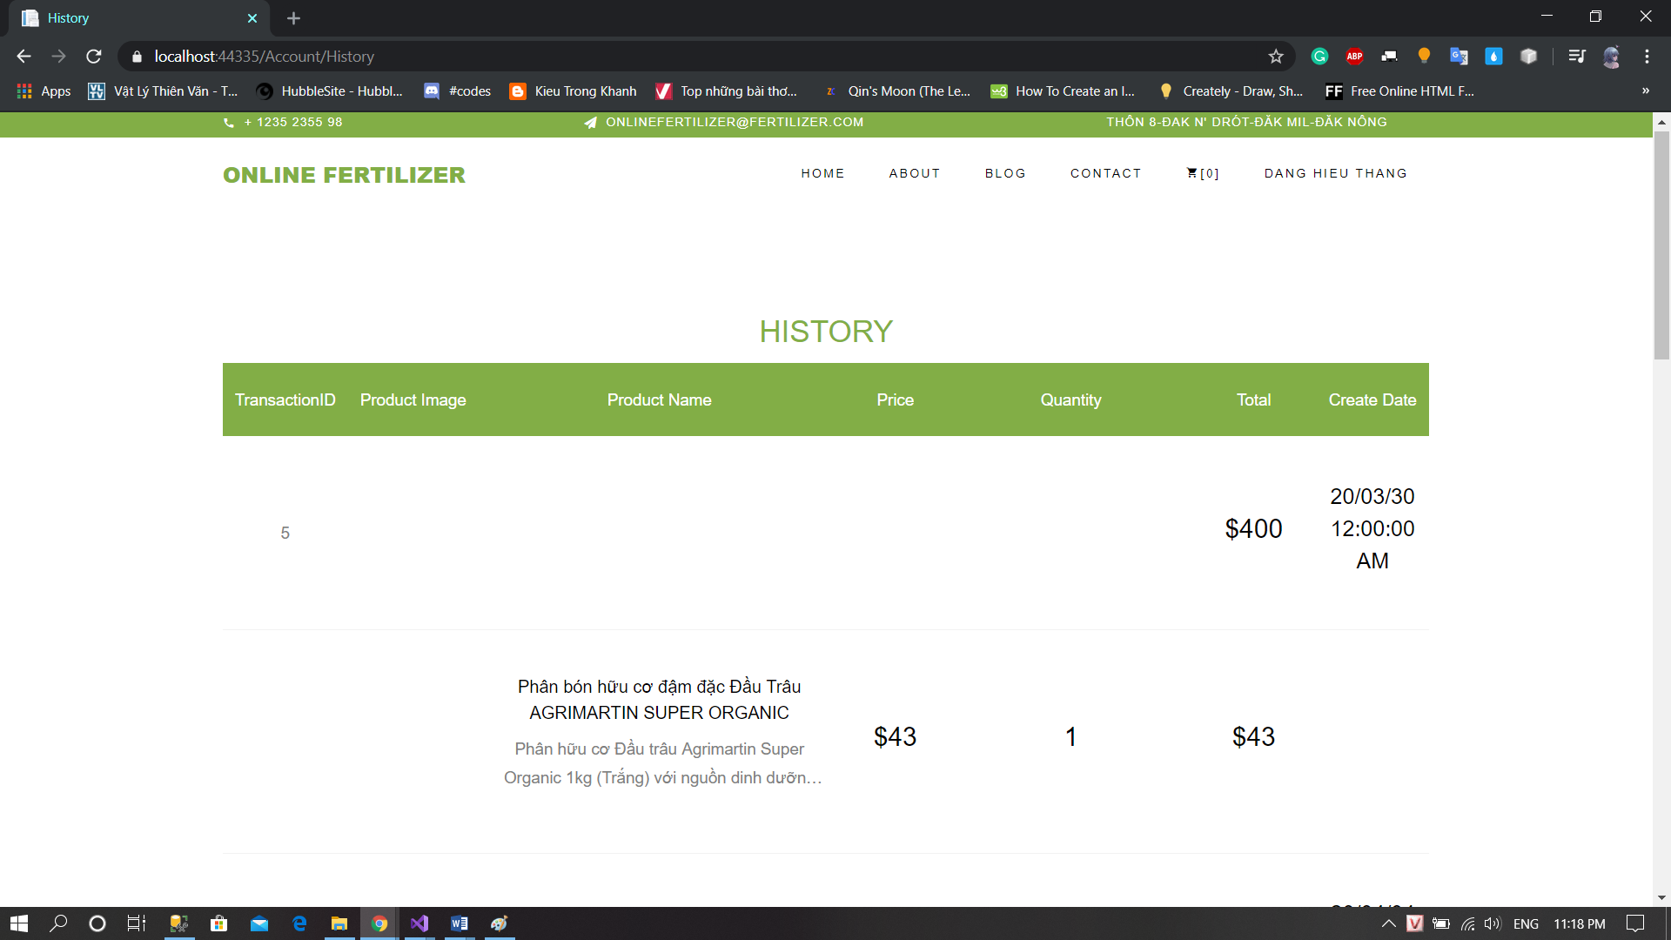

### Home Page

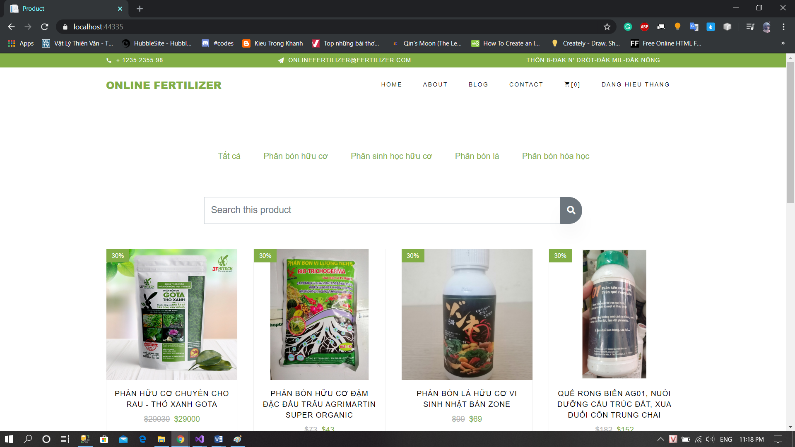

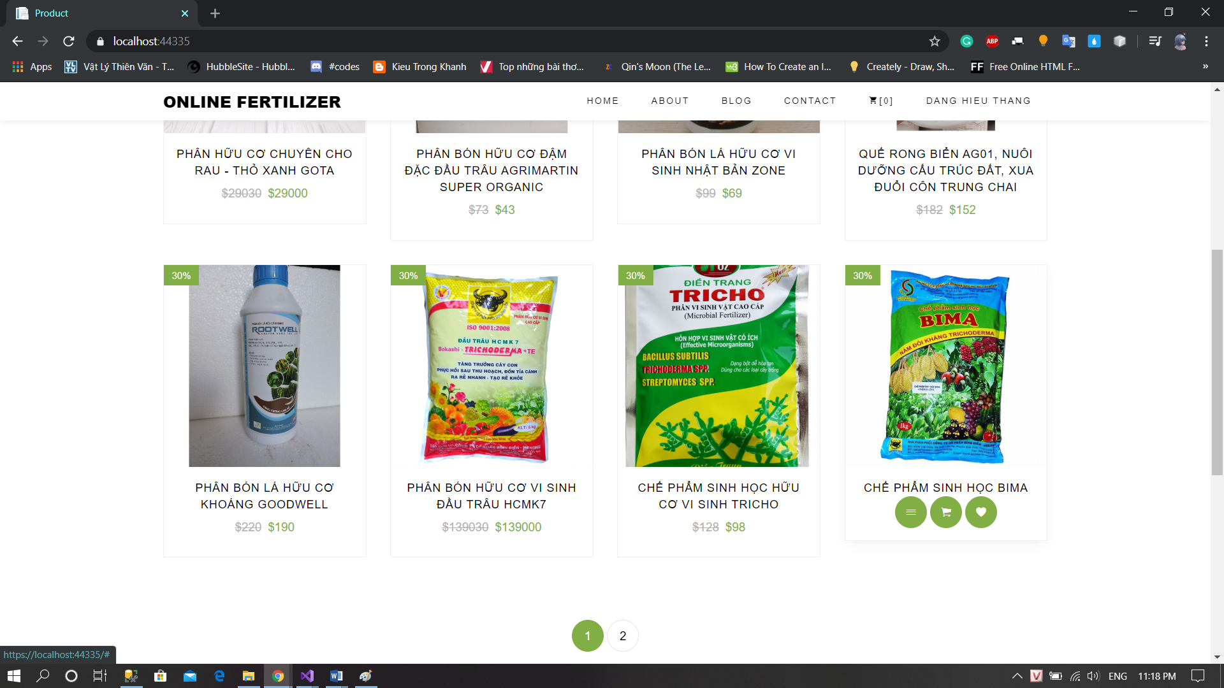

### Product Detail

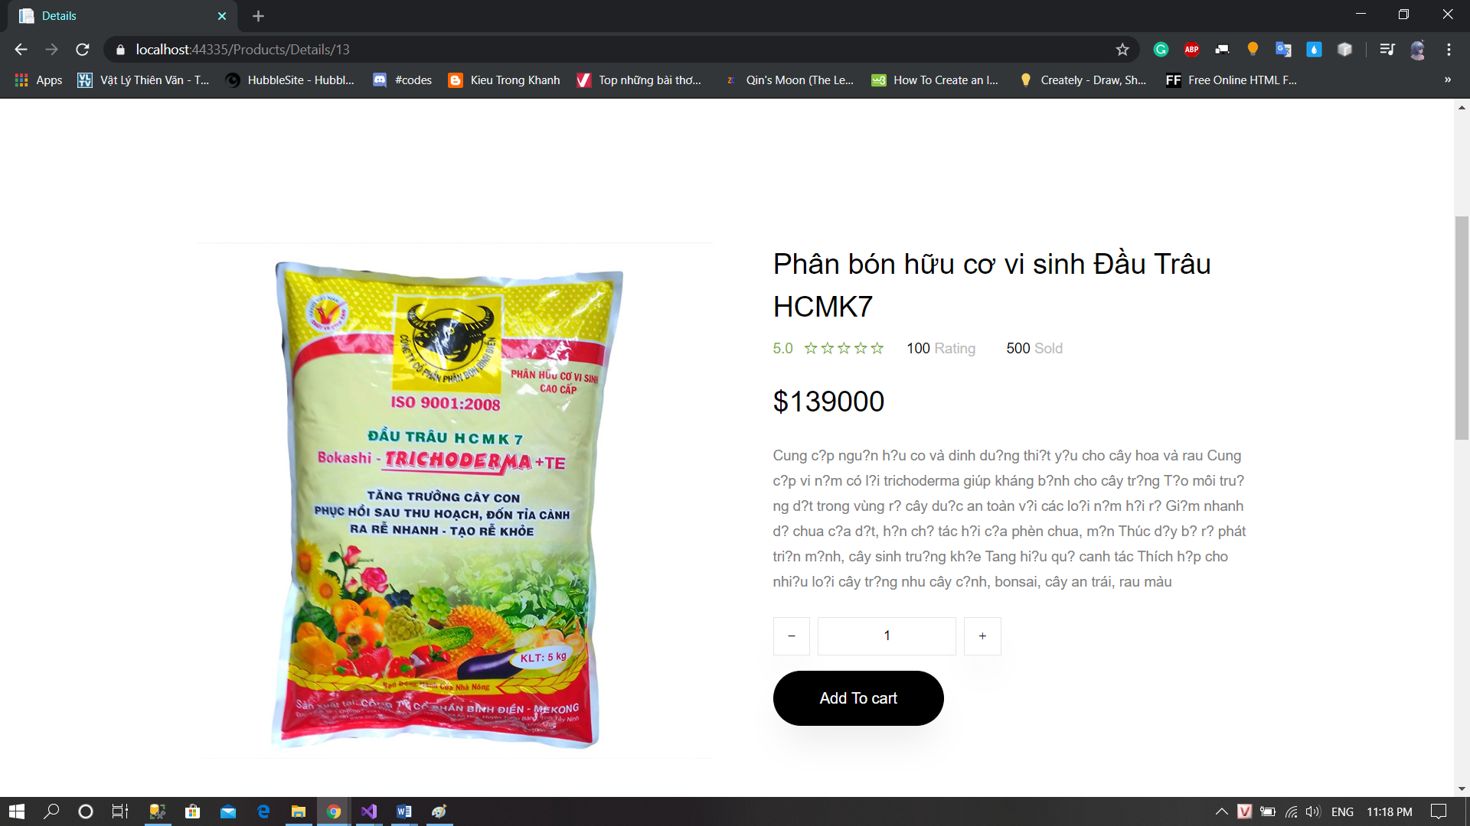

### Comment

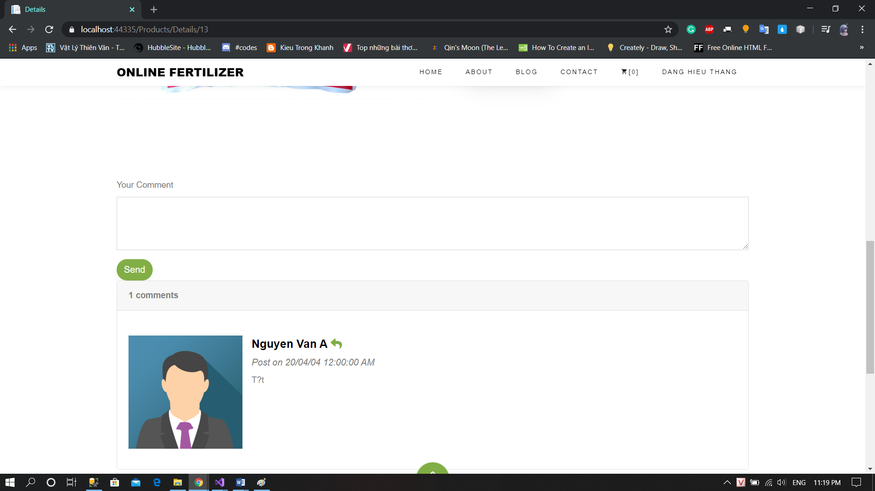

### View Cart

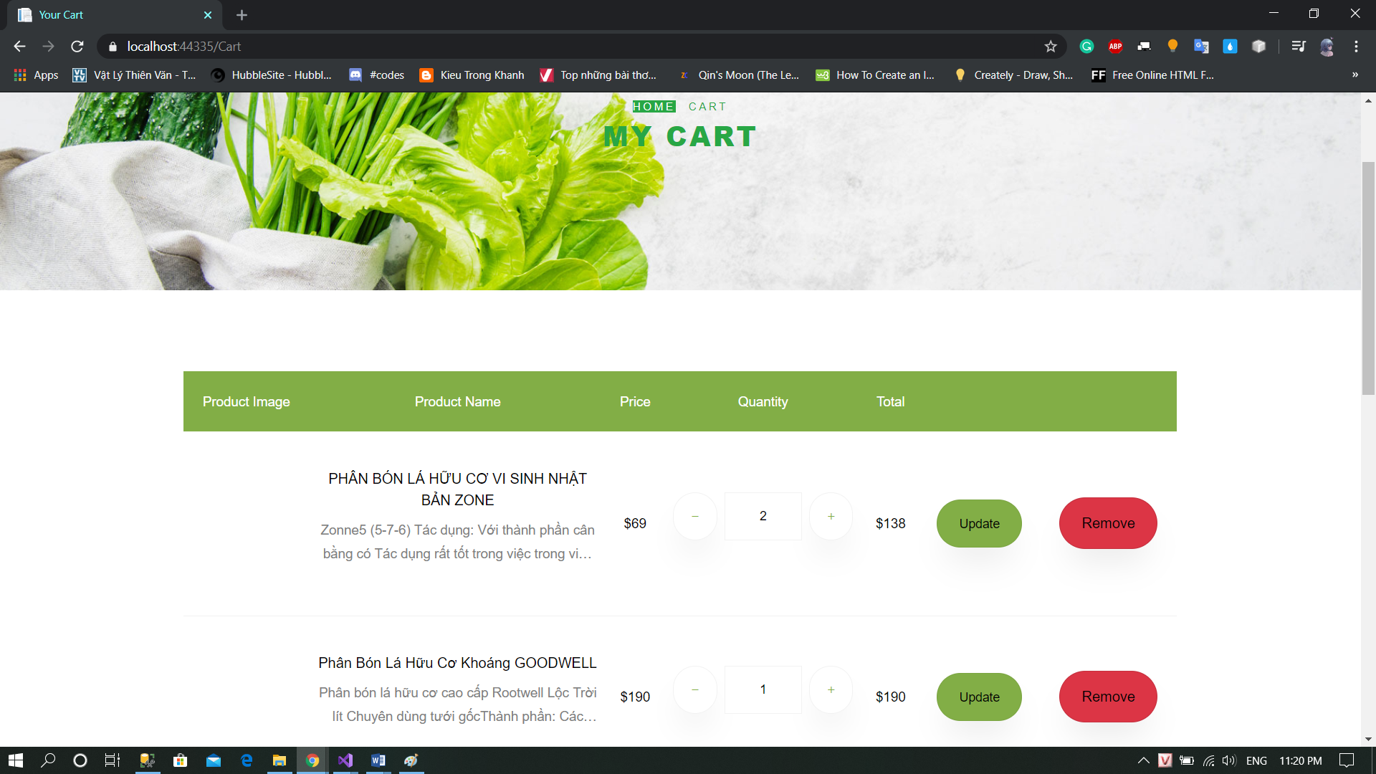

### Checkout

### 

# INTERFACE DEIGN APPLICATION

### Login

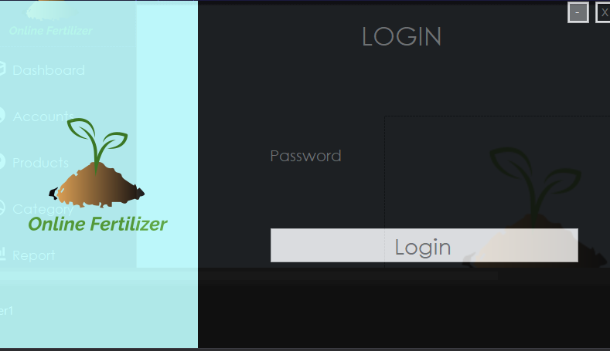

### Home Page

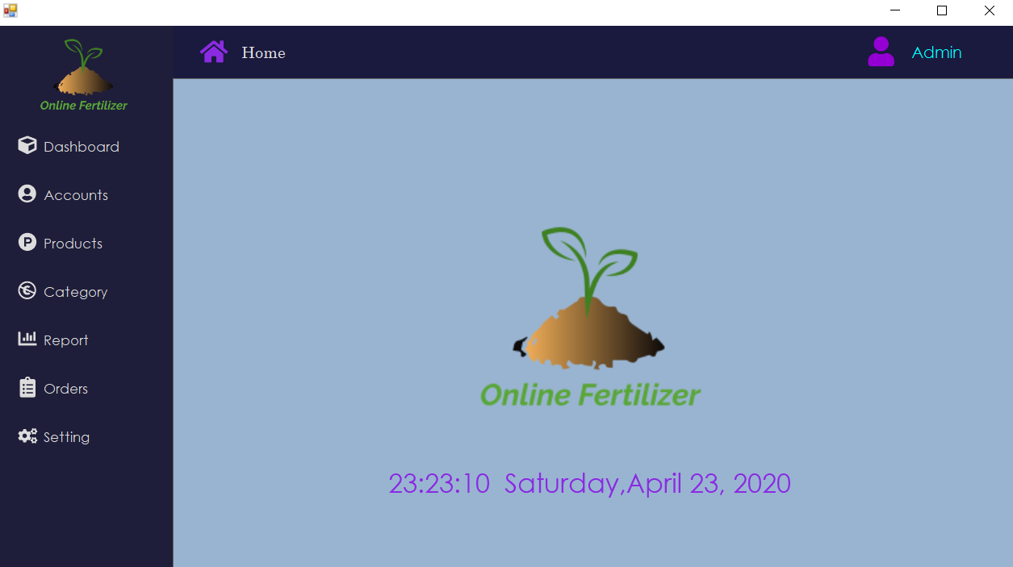

### Manager Accounts

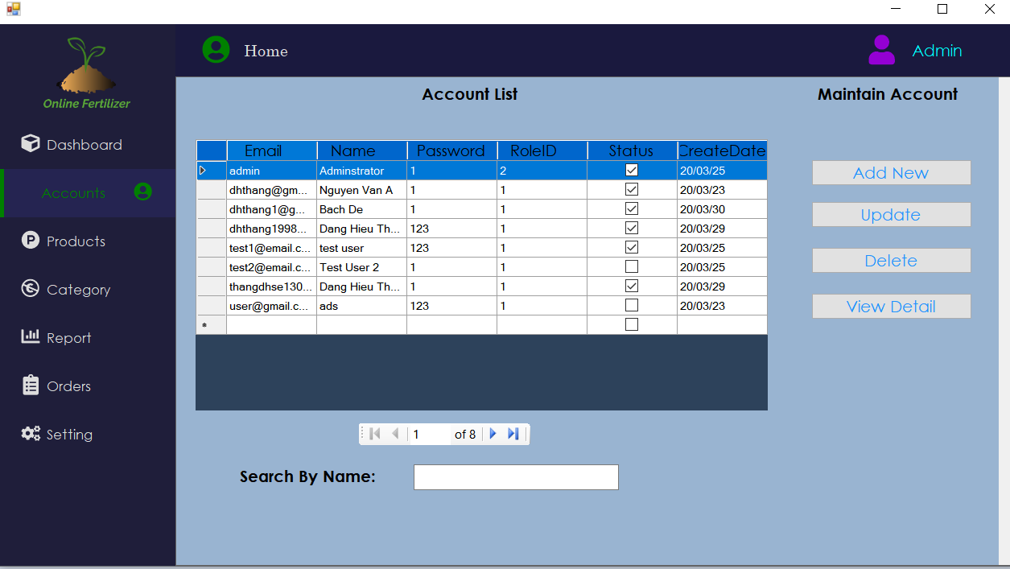

### Manager Products

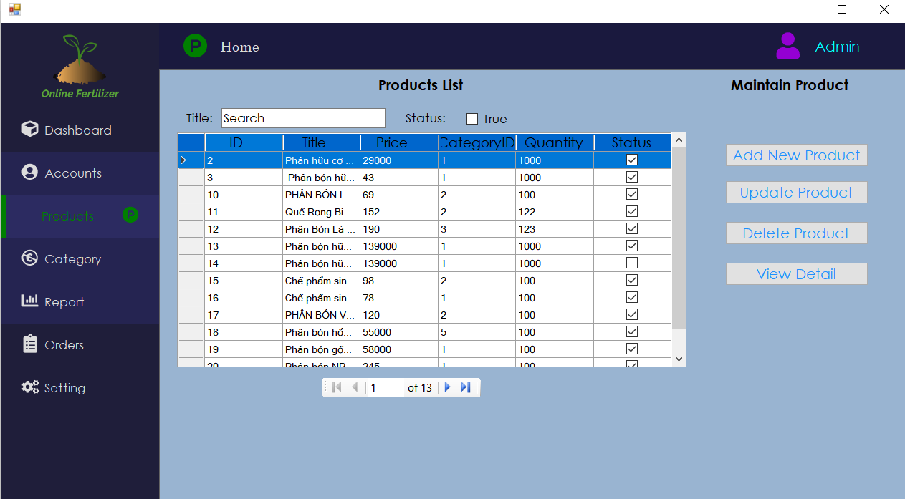

### Manager Category

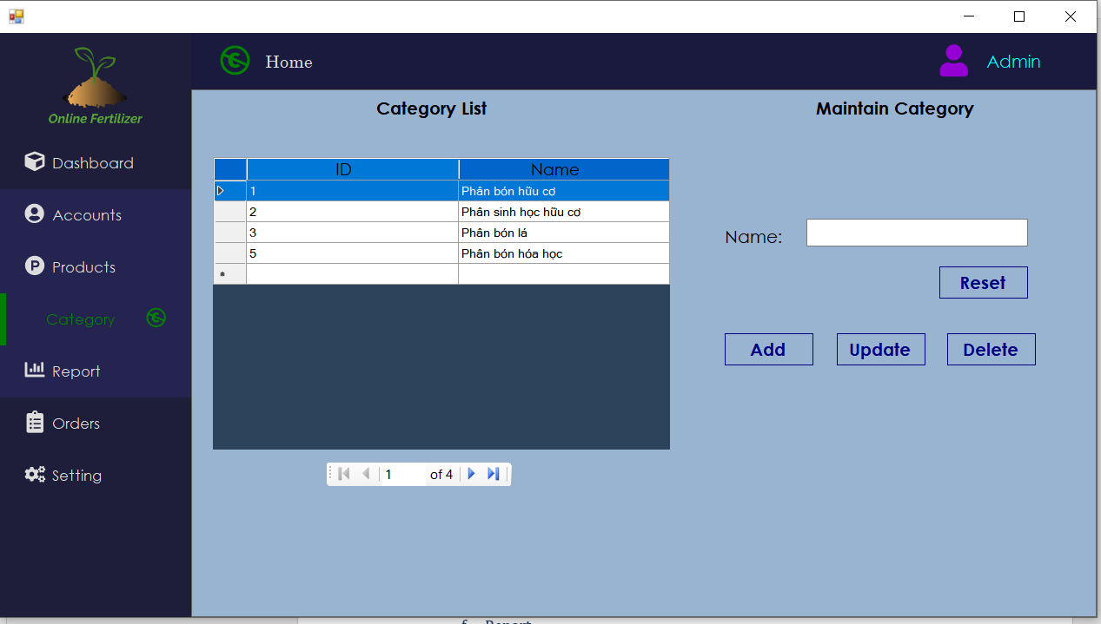

### Report

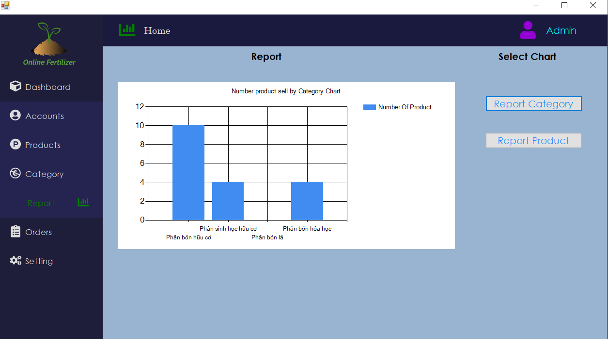

### Orders

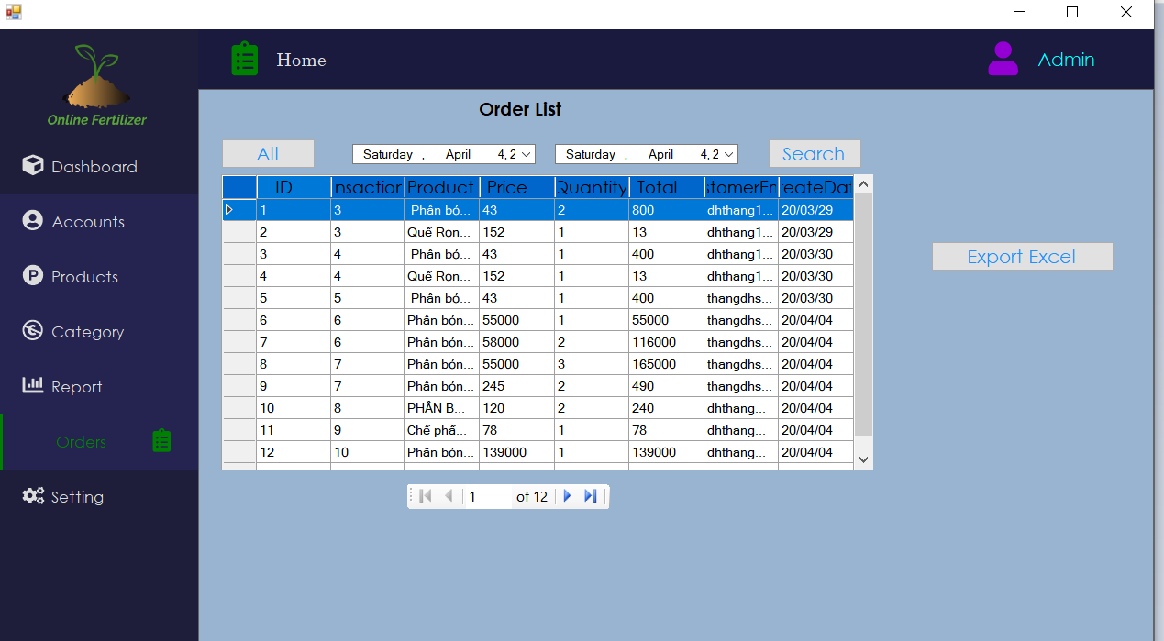

|  |  |  |
| --- | --- | --- |
| **Date: March 28, 2020** | **Prepared by Project Group T**  **Team Leader:** | **Approved by**  **Mr. Ho Hoan Kiem** |
| **Signature** |  |  |